Interco Finance Investment Questions
Name
Institution
Date

Interco Finance Investment Questions
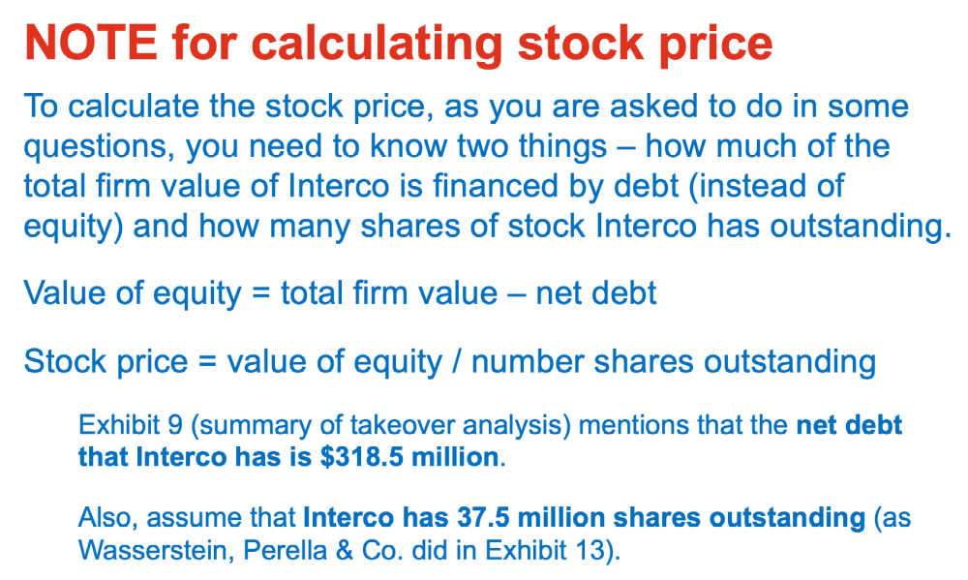
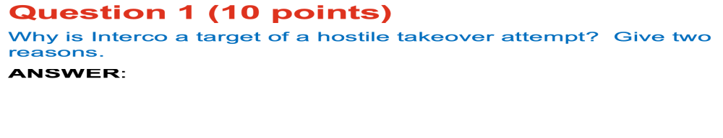
Question 1:
A hostile takeover refers to an acquisition attempt of a target firms by another party, which uses the shareholders or fighting to replace the current management to achieve the approval of the acquisition. Further, the management of the targeted company usually opposes an unsolicited acquisition because of primary reasons that include;
First, undervaluation of the target company share prices. Specifically, the City Capital had significantly undervalued the Interco to an initial price of $64 per common share before adjusting to $70 per share. On the other hand, Interco’s financial adviser, Wesserstein Perella & Co, provided a higher valuation of the target company at a range of $68 - $80 per share that led to rejection of the unsolicited bid from City Capital.
Exhibit 10: Premium Paid Analysis reveals Rales’ offer yielded the least Average Premium over the stock price compare to the annual deals the target company received in 1988. For example, Rales’ one-day premium was 17.9% compared to 56.0%, 4-weeks Premium Paid assessment yielded 59.1% for Rales vis-à-vis 80.9%, and 52-week low showed 137.3% for Rales and 171.3%. A Premium Paid Analysis is an important tool to estimate a real value of a company during acquisition because it represent the gain or discount that the acquirer receives. Therefore, Exhibit 10 indicates an international undervaluation from City Capital, which validates the Board of Directors’ decision to reject the acquisition.
Second reason relates to the mixed performance of the four divisions that constitute Interco Company. The four operation areas include Apparel, General Retail Merchandising, Footware, and Furniture Strategic Business Units (SBUs). The company enjoyed continuous performance-improvement from the Footware and Furniture segments but exhibited a ditch in sales performance from the Apparel and General Retail Merchandising.
Exhibit 11 (b): Value Ranges by Business Segment portrays protracted sales increments from the Footware and Furniture at $890.4 M and $1,105.6M respectively compared to the annual sales of $813.2M by Apparel and General Retail’s $532.3M revenue. Further, similar pattern was apparent from an operating cash flow because of the high results from Furniture and Footware units at $175.3 and $10.3 respectively. Unfortunately, the Apparel and General Retail segments each recorded an annual operating cash flow of less than $50. Consequently, the effect of the poor performances evident in the two segments made the Interco Company susceptible to hostile takeovers.
Besides, the City Capital disclosed its primary purpose of acquiring the Interco was to undertake restructuring by selling parts of the Footwear and General Retailing units. The City Capital accumulated 8.7% of the Interco common shares before its decision to acquire the latter business. The management resolution to amend the Shareholders’ Right Plan using Severance Agreement and ‘poison-pill’ shareholders right were defensive mechanisms to deter unsolicited takeovers because they accorded the Board with sole discretion to lowering percentages.
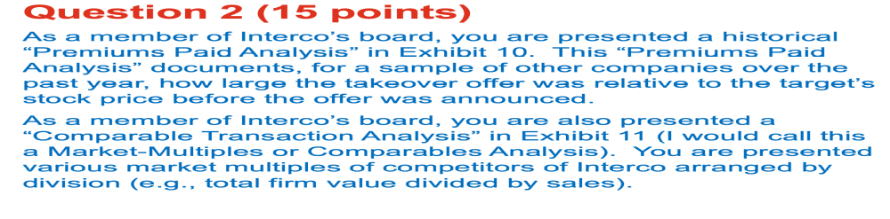
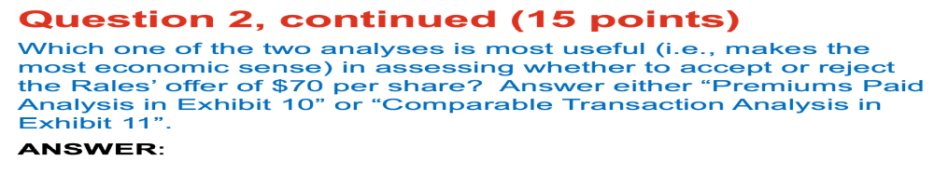Question 2:
PREMIUM PAID ANALYSIS-Exhibit 10.
-The City Capital aims to acquire the majority stakes to facilitate the acquirer assume complete control of the Interco Company. Therefore, a Premium Paid Analysis merits in this scenario because it outlines the value of control-premium the Interco shareholders would have lost. Specifically, exhibit 10 indicates several time zones that include one-day, 4 weeks, 52-week low, and 52-week high analyses, which improves the reliability of the premium paid test. The multiple time parameters used in the analysis helps to address the effect of fluctuating market conditions and influence speculative trading. Compassion between Rales offer and the 40 precedent transactions portrays the City Capital takeover bid as unsatisfactory because it was inferior to acquisition premium from one-day, 4-weeks, and 52-weeks low by 38.1%, 21.8%, and 34.0% respectively.
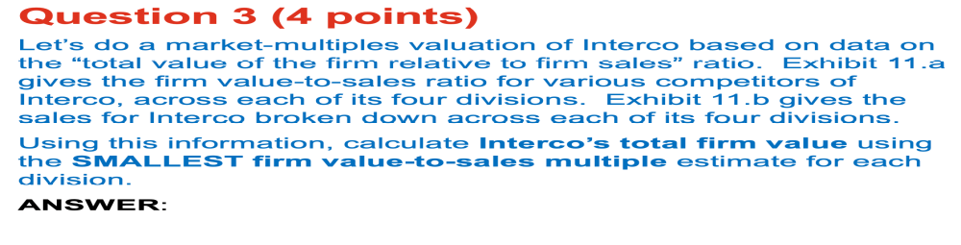Question 3:
(a). Total firm value in the General Retail Merchandising,
Enterprise Value= 0.6*sales
=0.6*532.3
=$319.38M
b. Firm value in Apparel Division
Enterprise Value= 0.4*sales
=0.4*813.2
$325.28M
c. Firm’s value in Footware Division
Enterprise Value= 0.5*sales
=0.5*890.4
$445.20M
d. Firm’s Value in the Furniture Division
Enterprise Value= 0.8*sales
= 0.8*1105.6
$884.48 M
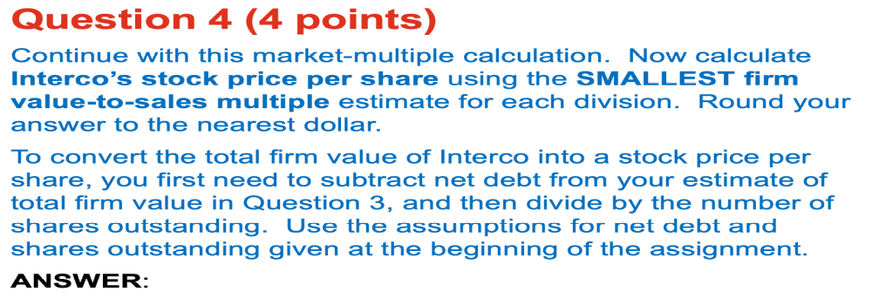
Question 4:
(a). Total firm stock price per share in the General Retail Merchandising,
(Enterprise Value of equity- net debt) ÷ number of shares outstanding
=$(319.38- 318.5) ÷37.5
=0.88÷37.5
=$0.02 per share
b. Firm value in Apparel Division
(Enterprise Value of equity- net debt) ÷ number of shares outstanding
=$(325.28 - 318.5) ÷37.5
=6.78÷37.5
=$0.18 per share
c. Firm’s value in Footware Division
(Enterprise Value of equity- net debt) ÷ number of shares outstanding
=$($445.20 - 318.5) ÷37.5
=126.7÷37.5
=$3.00 per share
d. Firm’s Value in the Furniture Division
(Enterprise Value of equity- net debt) ÷ number of shares outstanding
=$(884.48 - 318.5) ÷37.5
=565.98÷37.5
=$15.00 per share
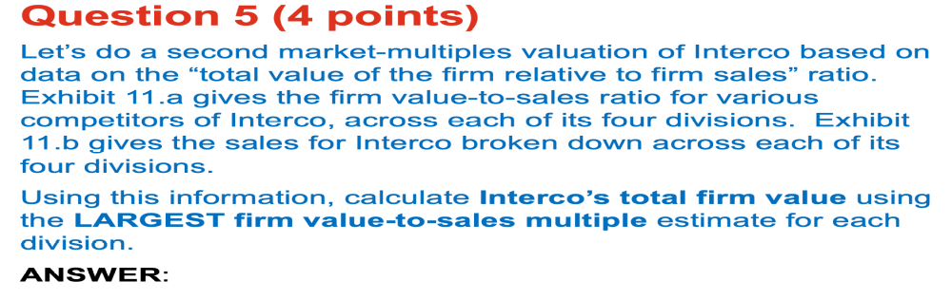
Question 5:
(a). Total firm value in the General Retail Merchandising,
Enterprise Value= 0.6*sales
=0.6*532.3
=$319.38M
b. Firm value in Apparel Division
Enterprise Value= 0.9*sales
=0.9*813.2
$731.88M
c. Firm’s value in Footware Division
Enterprise Value= 2.1*sales
=2.1*890.4
$1,869.84M
d. Firm’s Value in the Furniture Division
Enterprise Value= 2.1*sales
= 2.1*1,105.6
$2,321.76M
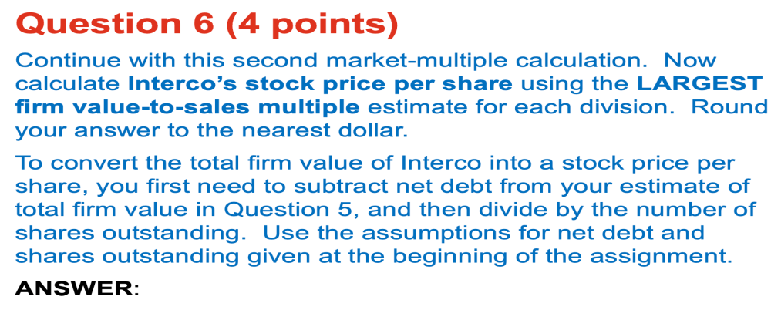
Question 6:
(a). Total firm stock price per share in the General Retail Merchandising,
(Enterprise Value of equity- net debt) ÷ number of shares outstanding
=$(319.38M - 318.5) ÷37.5
=0.88÷37.5
=$0.02 per share
b. Firm value in Apparel Division
(Enterprise Value of equity- net debt) ÷ number of shares outstanding
=$(731.38- 318.5) ÷37.5
=412.88÷37.5
=11.01013
=$11.00 per share
c. Firm’s value in Footware Division
(Enterprise Value of equity- net debt) ÷ number of shares outstanding
=$(1869.84 - 318.5) ÷37.5
=1551.34÷37.5
=41.3690
=$41.00 per share
d. Firm’s Value in the Furniture Division
(Enterprise Value of equity- net debt) ÷ number of shares outstanding
=$(2321.76- 318.5) ÷37.5
=2003.26÷37.5
=53.4202
=$53.00 per share
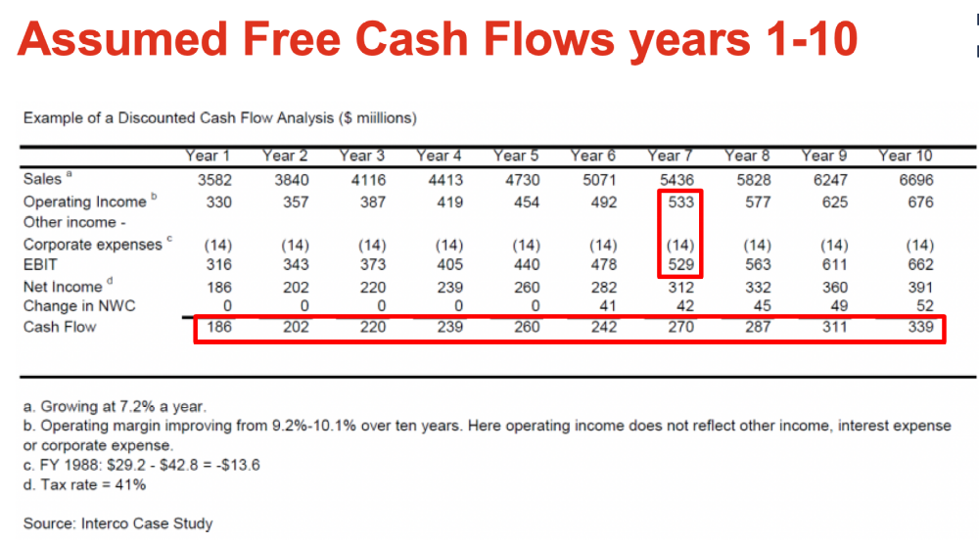
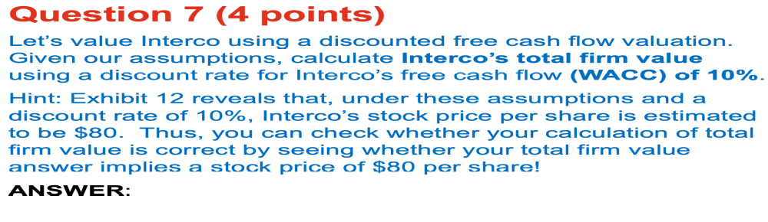
Question 7:
Firm Value= 186/ (1.1)¹ + 202/1.1)² +220/1.1)³ + 239/1.1)⁴ + 260/1.1)⁵
+ 242/1.1)⁶ + 270/1.1)⁷ + 287/1.1)⁸ + 311/1.1)⁹ + 339/1.1)¹⁰ + 4746/(1.1)¹⁰
FFCF= 169.09+166.94+165.29+163.24+161.44+136.60+138.55+133.89+131.89+130.70+1829.79
Total Firm’s Value= $3,327.42M
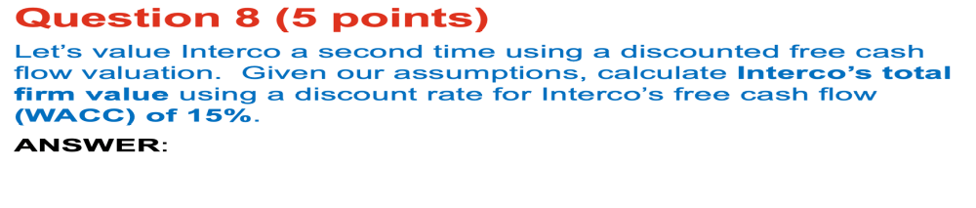
Question 8:
Firm Value= 186/ (1.15)¹ + 202/1.15)² +220/1.15)³ + 239/1.15)⁴ + 260/1.15)⁵
+ 242/1.15)⁶ + 270/1.15)⁷ + 287/1.15)⁸ + 311/1.15)⁹ + 339/1.15)¹⁰ + 4746/(1.15)¹⁰
FFCF= 161.74+152.74+144.65+136.65+129.27+104.62+104.62+101.50+93.82+88.41+83.80+1173.14
Total Firm’s Value= $2,370.34M
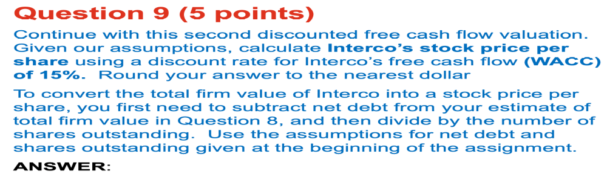
Question 9:
Interco’s Stock Price= (firm’s value - net debt) ÷ number of outstanding stock
Stock price = (2370.34 -318.5) ÷ 37.5
Stock price =2051.84÷ 37.5
Stock price= $54.715
The stock price =$55.00
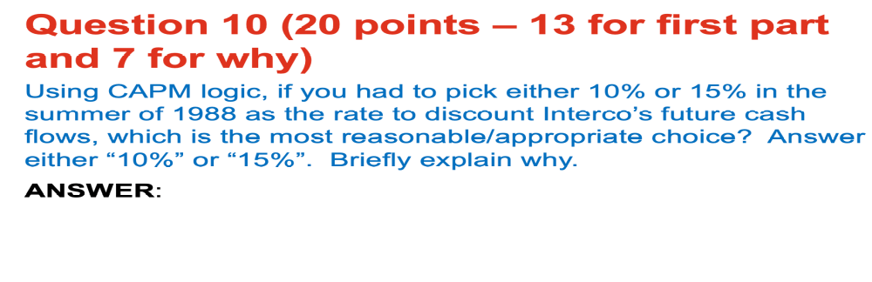
Question 10:
10%-rate of discount;
A CAPM model provides a linear relation that involves the level of investment risk and the required return rate to an investor. The CAPM logic implies that ordinarily, an investor is attracted to a riskier asset by the possibility of earning higher returns. However, the case of Interco does not guarantee an investor more return by when the WACC rate of discount is 15%. For example, the value of the firm when the WACC discount rate is 10% is $3,327.42 million when computed using a discounted cash flow. Conversely, a higher WACC discount rate results in a minimal value of $2370.34 million. The second scenario with higher discount rate implies the investor incurred more risk but earn less return on investment at the end of the investment. Therefore, a 10% discount rate is a reasonable choice from a rational investor’s perspective.

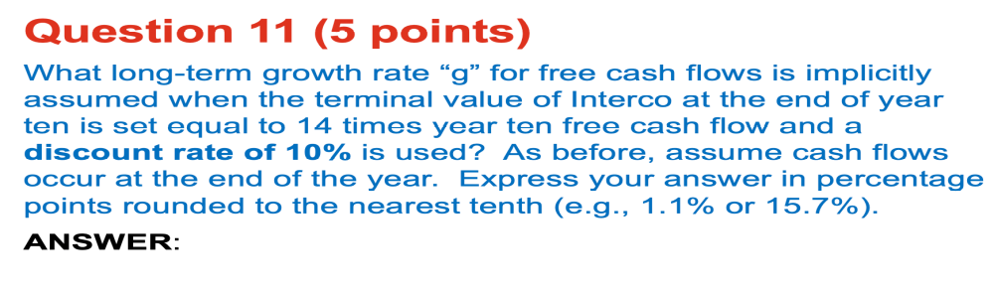Question 11:
The formula for calculating the terminal value is:
TV = (FCFn x (1 + g)) / (WACC – g)
Where:
TV = terminal value
FCF = free cash flow
g = perpetual growth rate of FCF WACC
Therefore, manipulating the equation above to determine the value for ‘g’, which is the long-term growth-rate for the FCF.
4746= 339*(1+g)/ 0.1- g
4746(0.1-g) = 339+ 339g
474.60 - 4746g =339 +339g
474.60-339 = 339g+4746g
135.60 = 5085g
g=135.60÷5085
g=0.0267*100%
g=2.67%
Long-term Growth Rate = 2.7%

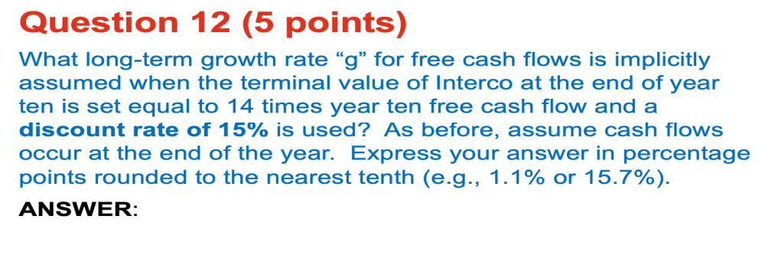Question 12:
The formula for calculating the terminal value is:
TV = (FCFn x (1 + g)) / (WACC – g)
Where:
TV = terminal value
FCF = free cash flow
g = perpetual growth rate of FCF WACC
Therefore, manipulating the equation above to determine the value for ‘g’, which is the long-term growth-rate for the FCF.
4746= 339*(1+g)/ 0.15-g
4746(0.15-g) = 339+ 339g
711.90 - 4746g =339 +339g
711.90 -339 = 339g+4746g
372.90 = 5085g
g=372.90÷5085
g=0.0733*100%
g=7.33%
Long-term Growth Rate = 7.3%

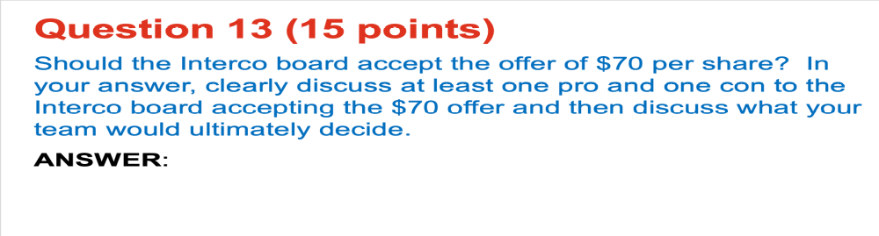
Question 13:
Yes, the Interco Board should accept the offer of $70 per share.
Among the key benefits of accepting the $70 per share bid relates to the premium-acquisition the company receive. Several valuation methods that include a value-to-sale multiple and Discounted Cash Flow method reveals the actual stock price for the Interco ranges from $53 to $55 per share. Therefore, accepting Hares’ price valuation of $70 per share present an acquisition-premium of 30% {($70-$54)/$54} or 27% {($70-$55)/$55}.
Conversely, accepting City Capital valuation price of $70 per share limits the ability to gain the highest acquisition-premium from the market. For example, exhibit 10 reveals an average premium-paid over stock price from a one-day basis, 4-weeks basis, and 52-weeks low would have yielded the company a higher acquisition-premium by 38.1% (56.0-17.9), 21.8% (80.9-59.1), and 34.0% (171.3-137.3) respectively. Moreover, the caliber of takeover bid manifest an unsolicited bid because the sole purpose that attracted take-over attempt is the undervaluation of the firm because of the dwindling performance in two divisions. Consequently, it is strategic for the current management to institute restructuring and achieve a high-valuation than a hostile takeover.

